Wire less System Documentation

A. Learning Center Location (Main)

Contents:

1 Rocket M5 with Grey Ethernet cable
1 LAN/POE power brick (Large)
1 Tripod tower
1 D-Link 5 port Ethernet switch
--Power brick labeled D-Link
1 500 Gigabyte Western Digital external hard drive labeled SYS1
--SS USB 3.0 (2.0) cable
1 Genesi SmartTop labeled SYS1/Tanzania
--Power brick labeled Delta Electronics
1 Linksys Wireless G Router (WRT54GS)
--Power brick labeled Linksys (Grey)
Ethernet cables

Installation Instructions:

Prior to installation, ensure that there are enough AC power outlets for each of the power bricks.

- Connect the Rocket M5 to the tripod tower using the provided hardware.
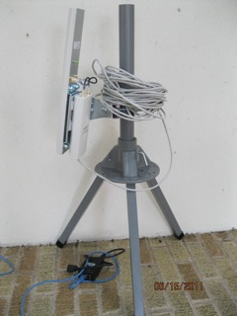Illustration 1: Rocket M5 with Grey Ethernet cable and Large power brick.
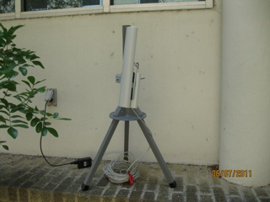Illustration 2: Another view of the Rocket M5

- Connect the Grey Ethernet cable from the Rocket M5 to the POE Ethernet port in the Large LAN/POE power brick.
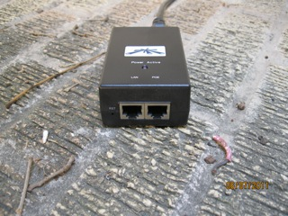
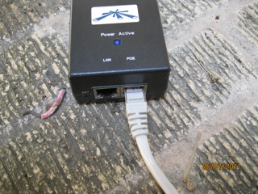

- Locate 1 Ethernet cable and connect it into the LAN Ethernet port in the Large LAN/POE power brick.
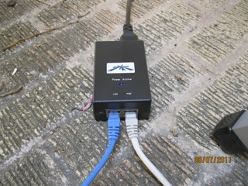Illustration 5: LAN/POE Power Brick with both LAN and POE connected. LAN goes out to the Linksys Wireless G Router. POE goes out to the Rocket M5.

- Connect the Ethernet cable from the LAN Ethernet port into 1 of the Linksys Wireless G Router Ethernet ports labeled 1-4.

Illustration 6: LAN/POE power brick with both LAN and POE connected. LAN will connect to the Linksys Wireless G Router.
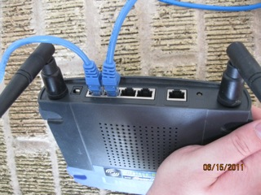Illustration 7: Linksys Wireless G Router. Note that the the serial ports labeled 1-4 are apart from the INTERNET port.

- Connect the Internet providing Ethernet cable to the Linksys Wireless G Router port labeled INTERNET.
Illustration 8: The INTERNET Port is apart from Ports 1-4 and is clearly labeled INTERNET.

- Locate 1 Ethernet cable and connect it into the Ethernet port in the Genesi SmartTop labeled SYS1.
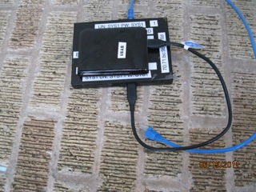Illustration 9: Genesi SmartTop with 500 Gigabyte Western Digital external hard drive on top.

- Connect the free end of the Ethernet cable in Step 6 into 1 of the ports labeled 1-4 of the Linksys Wireless G Router. (See illustrations for Step 5)

- Locate the the 500 Gigabyte Western Digital external hard drive marked SYS 1 and the SS USB 3.0 (2.0) cable. (See illustration above)

- Use the SS USB 3.0 (2.0) cable to connect the 500 Gigabyte Western Digital external hard drive to the Genesi SmartTop labeled SYS1.

- Plug in all power bricks.

- The system is ready to power on.

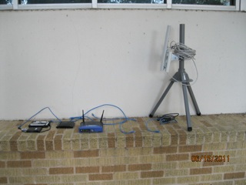Illustration 11: The completed system.
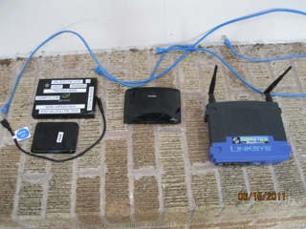Illustration 12: Components without the Rocket M5 in view. Note that the 5 Port Ethernet Hub is not in use.

B. Village Location (Remote1)

Contents:

1 Air Grid M5 with Grey Ethernet cable
1 Tripod tower
1 LAN/POE power brick (Small)
1 D-Link 5 port Ethernet switch
--Power brick labeled D-Link
1 500 Gigabyte Western Digital external hard drive labeled SYS2
--SS USB 3.0 (2.0) cable
1 Genesi SmartTop labeled SYS2
--Power brick labeled Delta Electronics
1 D-Link AirPlus G
--Power brick with Orange trim
1 Phone chord
1 MeterBus SunSaver connector with USB serial adapter
Ethernet cables

Installation Instructions:

Prior to installation, ensure that there are enough AC power outlets for each of the power bricks.

- Connect the AirGrid M5 to the tripod tower using the provided hardware.

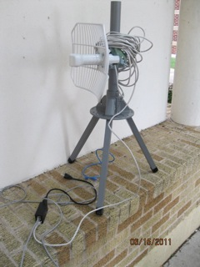Illustration 1: AirMax M5

- Connect the Grey Ethernet cable from the AirGrid M5 to the POE Ethernet port in the Small LAN/POE power brick.

- Locate 1 Ethernet cable and connect it into the LAN Ethernet port in the Small LAN/POE power brick.
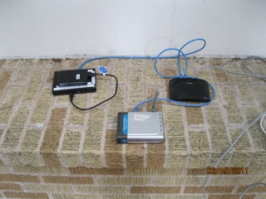Illustration 5: Left: Genesi SmartTop with the 500 Gigabyte external hard drive on top. Center: D-Link AirPlus G Router. Right: D-Link 5 Port Ethernet Switch.

- Connect the Ethernet cable from the LAN Ethernet port into 1 of the D-Link 5 Port Ethernet Switch ports. (See illustrations in Step 3)

- Locate 1 Ethernet cable and connect it into the Ethernet port in the Genesi SmartTop labeled SYS2.

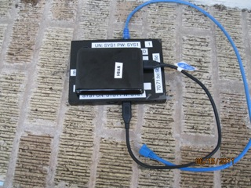Illustration 6: Genesi SmartTop with 500 Gigabyte external hard drive on top. Ethernet cable (blue) is also shown.

- Connect the free end of the Ethernet cable in Step 5 into 1 of the D-Link 5 Port Ethernet Switch ports.

Illustration 7: Right: D-Link 5 port Ethernet switch.

- Locate 1 Ethernet cable and connect it into the D-Link AirPlus G.

Illustration 8: Center: D-Link AirPlus G router.

- Connect the free end of the Ethernet cable in Step 7 into 1 of the D-Link 5 Port Ethernet Switch ports.

- Locate the the 500 Gigabyte Western Digital external hard drive marked SYS 2 and the SS USB 3.0 (2.0) cable.

- Use the SS USB 3.0 (2.0) cable to connect the 500 Gigabyte Western Digital external hard drive to the Genesi SmartTop labeled SYS2.

Illustration 9: Genesi SmartTop with 500 Gigabyte external hard drive on top.

- Locate the telephone chord and connect it to the MeterBus SunSaver connector with USB serial adapter.
  - The USB side will plug into the Genesi SmartTop. The free telephone chord connector will plug into the SmartSaver.

- Plug in all power bricks.

- The system is ready to power on.

